Housing Report Analysis Using Hadoop

By,
Vinay Chennupati (305079520)
Goutham Kumar Pola (304823433)
Sai Kumar Lakadram (305091194)
Department of Information Systems, California State University
Los Angeles

Abstract:

Searching a house particularly in a big city like Los Angeles is very difficult. The problem for searching a house is even higher when it comes to someone who comes from other parts of U.S or from other parts of the world for say fresh students who would like to join in CSULA. Since CSULA cannot provide the accommodation for the fresh incoming students due to its limitations it would be helpful insight if we analyze the data about the housing information where the houses are been available in the close vicinity to CSULA. Dataset we have used is very large and unstructured. So if we store our data set in Hadoop File System it would be very helpful. Hadoop distributed file systems provides scalable and reliable data storage in addition to enabling analytical capabilities over large amounts of data. Hadoop map reduce architecture model implementation will be instrumental in helping our process and analyze large data sets. In order to analyze our dataset we have used HiveQL because it is very to use if we have SQL background. The utility of using Hadoop to consume large amounts of data and enable analytical insights is what we aim to demonstrate.

Introduction:

Searching for a house in the city like Los Angeles is a tedious task and that to for a fresher who is new to Los Angeles it is very difficult to find the house and to know in which locality the houses are available and how many houses are available in the particular locality that they desire. So if we analyze the data regarding the housing addresses to find how many vacant houses are available in a particular area this would be really helpful for the fresher who are looking for houses in Los Angeles.

According to the housing board report there are more than 994,277 registered houses in Los Angeles where most of the houses are occupied by the occupants and few of them are vacant. If we provide the vacant details of the houses area wise it is very useful for the people who are in search on new house.

Background:

We have found the data set about the city address from lacity.org which contains the details of all the houses that are available in LA and which houses are vacant and to find which houses are occupied. So here in this project my insight is to take California State University, Los Angeles as the focal point and try to project all the houses in and order 50 miles of CSULA and also project the houses that are available in the close vicinity to CSULA, This kind of analysis actually helpful for the numerous number of students that are coming to CSULA from outside California when search for the houses.

Querying:

Data stored in HDFS can be queried using different programming languages, for our analysis we used Hive Query Language to extract the data as it provides an SQL-like structure and operates on tables just like an RDBMS, even though it does not strictly follow the full SQL standard. Hive queries are translated into Map reduce jobs which run on top of Hadoop cluster.

Services:

We used Microsoft Azure cloud computing platform as it provides both PAAS (Platform as a service) and IAAS (Infrastructure as a service) in addition to supporting different programming languages. For using Hadoop on Microsoft Azure, Azure HDInsight must be created and deployed. HD Insight provisions Hadoop clusters designed to store and analyze large data sets. HD Insight uses HortonWorks Data Platform (HDP) Hadoop distribution. This provides an ecosystem of components of like Hive, Pig etc.

Analysis of the dataset:

The dataset which we have collected consists of 994,277 values which is a csv file which is separated by a comma. This data set consists of the information about all the houses that are registered in L,A and the information regarding the houses in such a way that which houses are vacant and which houses are occupies. So in our analysis there are totally 877327 which are occupied and a total of there are some many houses that are registered I n the western part of Los Angeles when compared with all the other directions and the eastern part of Los Angeles the number of houses are less.

As per our analysis it is found that there are so many houses vacant in the street by name Figueroa, Sepulveda ete.. when we took focal point as CSULA in order to calculate number of houses available in and around CSULA for every 5 miles radius, we have found that in a radius of 0-5 mile we have around 17875 houses that are vacant. In the radius of 15-20 miles there are around 25229 houses that are vacant from CSULA. If any students want to stay close to the college the students have many available houses in the close vicinity.

Data Visualization:

Data visualization is projecting the relevant information in pictorial or graphical form. Hive query results can be visualized in Microsoft excel. We have used hive ODBC for data visualization in excel. Apart from Excel there are other powerful tools available for data visualization/dashboard creation like R and Tableau.

Graphical representation of few analysis:

Here are some of visualizations works
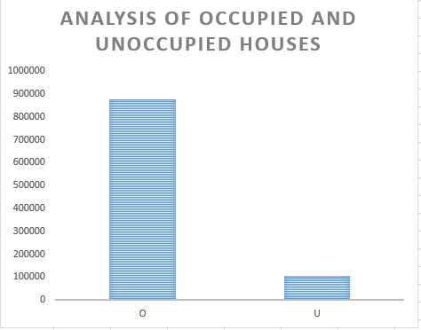
Figure (1) Number of houses that are occupies and unoccupied in L.A

As we can clearly see that there are as close as 100000 houses that are vacant in the city of Los Angeles.

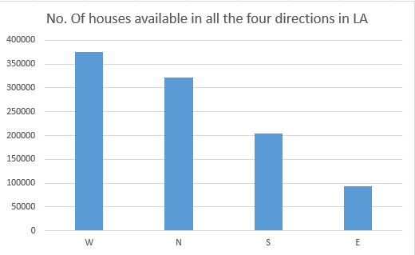
Figure (1) Number of houses that are in each direction of LA

Figure(2) shows that the number of registered house in LA are more in Western side of Los Angeles where the least number of houses are towards eastern side of Los Angeles.
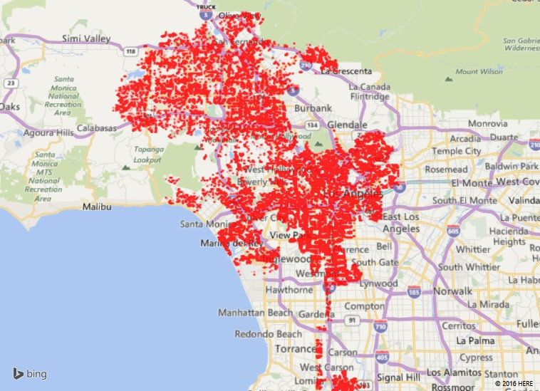
Figure (3) Number of houses that are registered in L.A

Figure (3) shows that total number of houses that are registered in and around Los Angeles. The above map plots the availability of different houses in L.A.

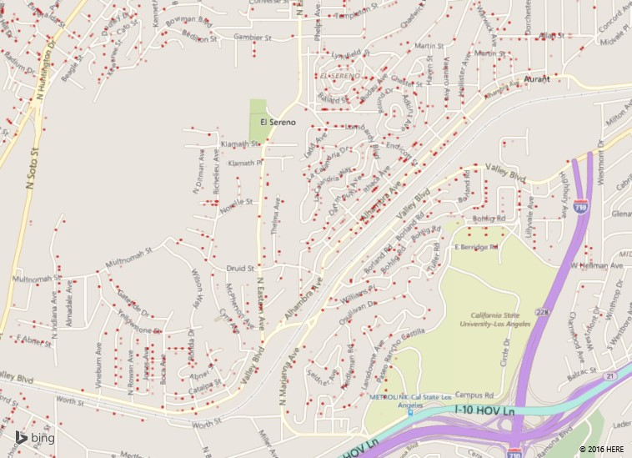
Figure (4) Number of houses that are available in and around CSULA in a radius of 0-10 miles

The above map shows all the available houses that available in and round California State University, Los Angeles.

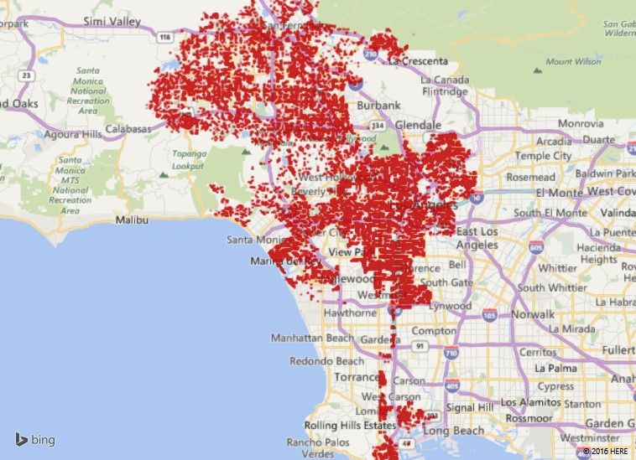
Figure (5) Number of houses that are available in and around CSULA in a radius of 0-10 miles which are not vacant.

Figure (5) shows that the number of houses that are available in a radius of 0-50 miles that are occupied.

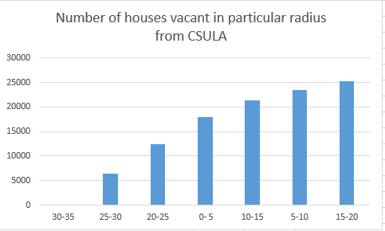
Figure (6) Number of houses that are unoccupied in and around CSULA in different miles radius.

From the Figure (6) if is seen that in a radius of 15-20 miles the houses and the least number of house are available in a radius of 30-35.

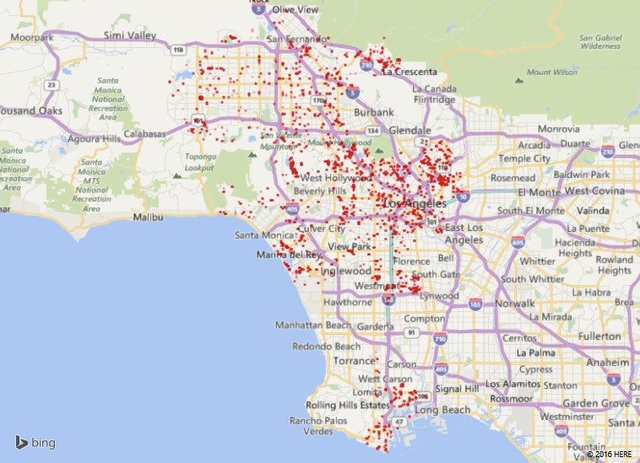Figure (7) Number of houses that are unoccupied in and around CSULA in different miles radius

Figure (7) is the map representation of figure (6).

Conclusion:

In the overall project we have learned to write queries in order to analyze the data, the functioning of map reducer function the usage of azure cloudberry storage blob visualization of the data with the help of Excel by using ODBC driver etc..
In our detailed analysis we have found that the number of houses in Los Angeles are available in the western part. From California state university as focal point more number of houses are available which are not occupied in a radius of 15-20 miles and the least are available in a radius 30-35. In a radius of 0-5 miles from California state university, Los Angeles there are about 16,000 vacant houses available.

Dataset URL:
http://catalog.data.gov/dataset/addresses-in-the-city-of-los-angeles

GitHub URL:
https://github.com/vinaychennupati/Housing-Addresses

References:
http://blog.cloudera.com/wp-content/uploads/2010/01/6-IntroToHive.pdf
http://blog.cloudera.com/blog/2013/04/demo-analyzing-data-with-hue-and-hive/
https://azure.microsoft.com/en-us/documentation/articles/hdinsight-hadoop-tutorial-get-started-windows/
https://azure.microsoft.com/en-us/documentation/articles/hdinsight-connect-excel-hive-odbc-driver/
https://hadoop.apache.org/docs/r1.2.1/mapred_tutorial.html
http://www.infoworld.com/article/2683729/hadoop/10-ways-to-query-hadoop-with-sql.html
https://docs.treasuredata.com/articles/hive-functions
https://cwiki.apache.org/confluence/display/Hive/LanguageManual+UDF

